Chapter 9: Straight line graphs
Worksheet B

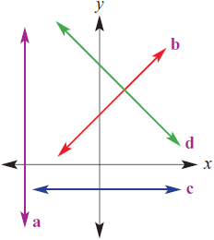
1 State whether the lines labelled a, b, c and d on this graph have a positive, negative,
zero or undefined gradient.

a ___________________________

b ___________________________

c ___________________________

d ___________________________

2 Find the gradients of the following lines.

a b
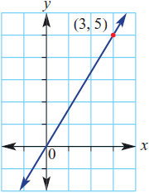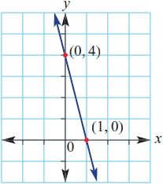

___________________________ ___________________________

___________________________ ___________________________

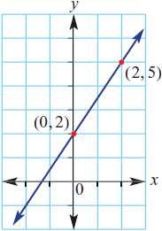
c

___________________________

___________________________

3 The volume of water in a large tank is initially 1000 L. The volume decreases by
200 L per minute for 5 minutes.

a Complete the following table of values using t for time in minutes and V for volume in litres.

t | 0 | 1 | 2 | 3 | 4 | 5
V

b Use the axes provided to draw a graph by plotting the points given in the table in part a.

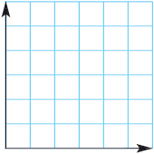

c Write a rule linking V with t.

_________________________________________________________________

d Use your rule to find the volume of water in the tank after 3.5 minutes.

_________________________________________________________________

_________________________________________________________________

e Use your rule to find how long it takes for the volume to fall to 750 L.

_________________________________________________________________

_________________________________________________________________

_________________________________________________________________

